**IST 263 Project Milestone 6 – First Draft Using CSS**

**Name**: Ricki Nalitt

**Description:**  
For my website I will be creating a food blog. My audience is college students. This will include a couple sections on restaurant suggestions in Syracuse and around New York. Another section will include recipes that you can make at home for breakfast, lunch, dinner, dessert and snacks. Others will include trending foods, restaurants, areas, and ingredients. Overall, I will be giving suggestions of restaurants, recipes, and ingredients for people of all ages and genders to have easy access to.

**What is the url of the page you choose to work on for this part?**

https://rbnalitt.github.io/ist263/project/page1.html

**Paste a screen shot of the wireframe you created for this page below.**

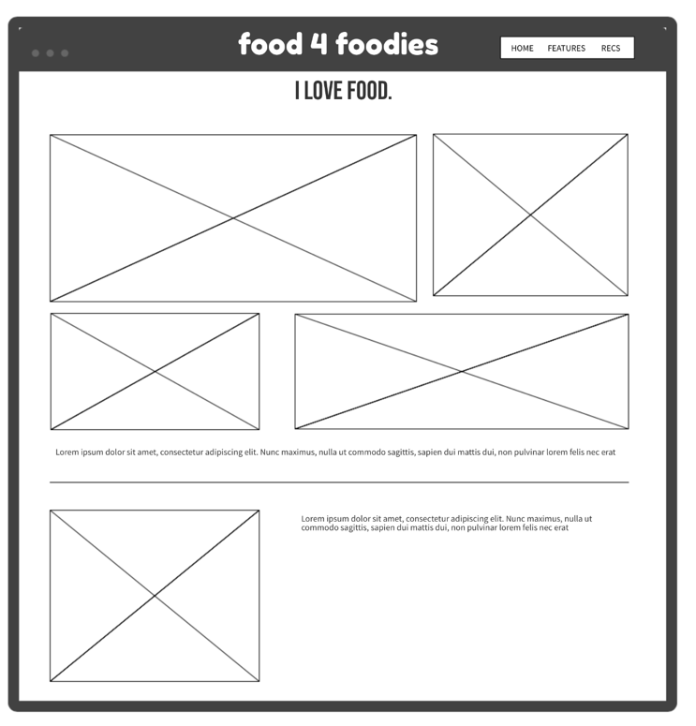

**Provide the URL of the WAVE checker for this page below.**

**Provide the URL of the HTML validator for you page below.**

https://html5.validator.nu/?doc=https%3A%2F%2Frbnalitt.github.io%2Fist263%2Fproject%2Fpage1.html

**If something went wrong in this part, describe what happened and how you can fix it moving forward.   
Examples of problems could be, page isn’t responsive, page doesn’t look like wireframe, etc.**